**BANK LOAN ANALYSIS**

**MOHANISH GUPTA**

**PROBLEM STATEMENT**

**Total Loan Applications: We need to calculate the total number of loan applications received during a specified period.**

**it is essential to monitor the Month-to-Date (MTD) Loan Applications and track changes Month-over-Month (MoM)**

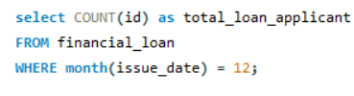

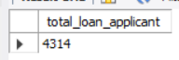

**Total Funded Amount: Understanding the total amount of funds disbursed as loans is crucial.**



**We also want to keep an eye on the MTD Total Funded Amount and analyse the Month-over-Month (MoM) changes in this metric**

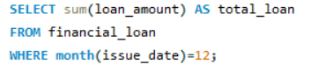

**Total Amount Received: Tracking the total amount received from borrowers is essential for assessing the bank's cash flow and loan repayment.**



**We should analyse the Month-to-Date (MTD) Total Amount Received and observe the Month-over-Month (MoM) changes.**

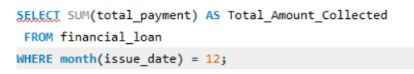

**Average Interest Rate: Calculating the average interest rate across all loans**





**Average Debt-to-Income Ratio (DTI): Evaluating the average DTI for our borrowers helps us gauge their financial health**



**Good Loan Percentage**

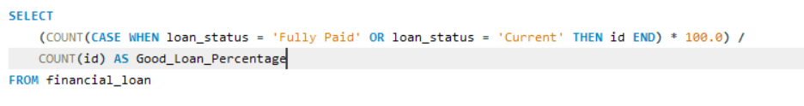



**Good Loan Applications**

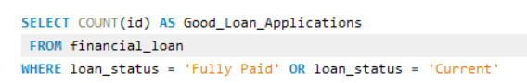

**Good Loan Funded Amount**



**Good Loan Amount Received**

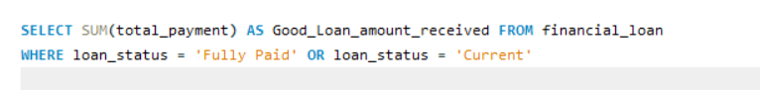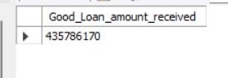

**Bad Loan Percentage**

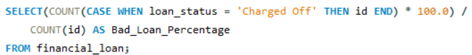

**Bad Loan Applications**



**Bad Loan Funded Amount**

**Bad Loan Amount Received**

**LOAN STATUS**

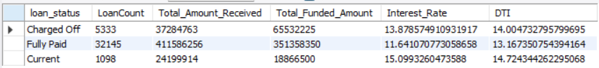

**LOAN STATUS MONTHLY**

**LOAN STATUS BASED ON STATE**

LOAN STATUS BASED ON TERM

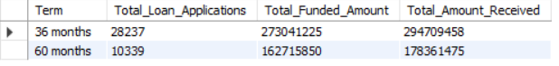  
  
  
  
LOAN STATUS BASED ON EMPLOYEE LENGTH

LOAN STATUS BASED ON PURPOSE

LOAN STATUS BASED ON HOME OWNERSHIP

